Guide To Approving and Rejecting POs in Oracle ERP System

When your approval for a requisition is required to you will receive an Email with a link attached. See example below :

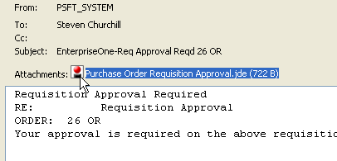

1. Open the eMail and double click on the attached link. When you see the
following window click “Open”

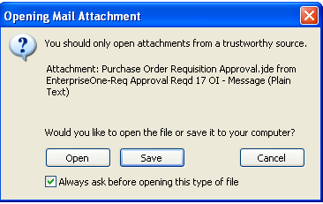

2. Log onto the system with username and password and click “OK”

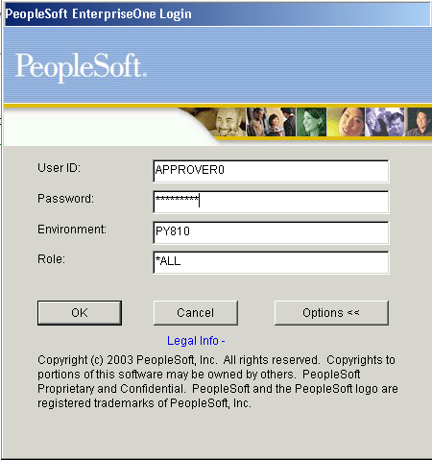

3. Open your menu by clicking on the (just like Windows Explorer)

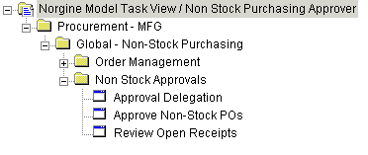

Double click on the “Approve Non Stock POs” option.

- You will be taken to “Work With Orders Awaiting Approval” screen.
(Your user ID will automatically be filled in for you – this will be based on your login)

Do not change any of the default entries, just click on the “Find” Button to display all the
Purchase Orders that are awaiting your approval.

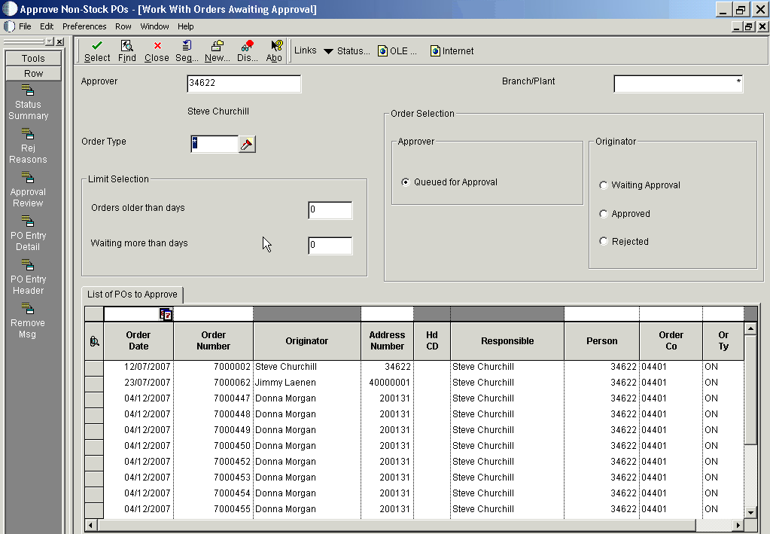
POs waiting approval

5 To select a single order, move your cursor pointer so that it is pointing a the required line and
click once so that the line is highlighted then click on the “Select” button at the top.

To select a BLCOK of POs in one go, move your cursor to point to the first PO, click once
to highlight it, then move your cursor to point to the last PO hold the shift key down and click
on the last PO – this will highlight the block of PO’s you want to approve. Then click on the
“Select” button at the top.

To select several individual PO’s in the list, move your cursor to point to the first PO, click
once to highlight it, then move your cursor to point to the next PO you want to select and hold
the Ctrl key down and click on the required PO line – repeat this for each of the PO’s you
want to select – each selected PO will be highlighted. Then click on the “Select” button at the
top.

6. Once you have selected your PO’s

7 Once you click select in step 6, you will be taken to the Approval Screen showing the details
of the chosen PO – if you have selected more than one then the details of the first PO selected
will be shown.

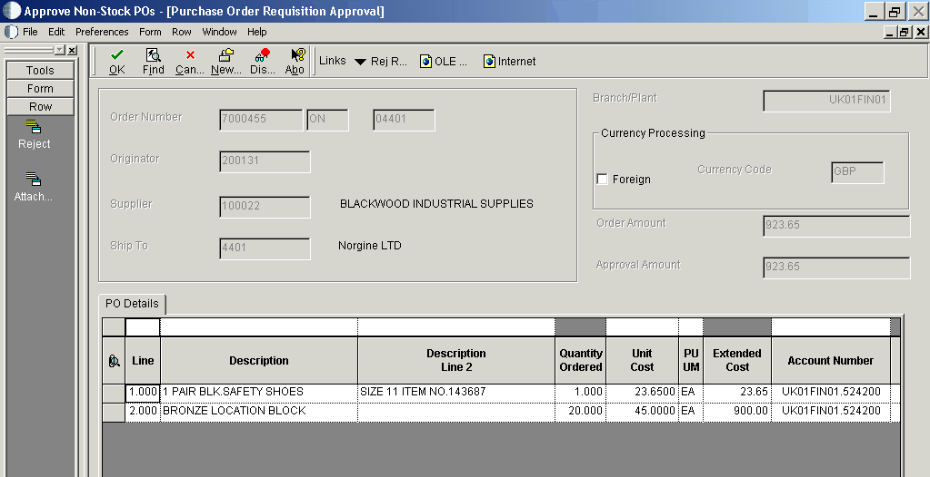

To approve the requisition follow steps 8 – 12
To reject the requisition follow steps 13 – 18

To Approve a PO.

8 Position your cursor over the first box of the PO line. The cursor will change to a small black arrow Click once and the line will be highlighted

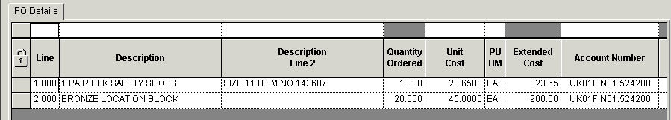

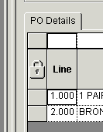

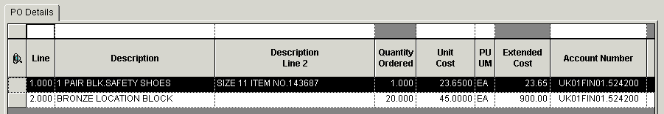

9. On the top left hand side of the screen click the word “Form”

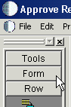

10. This will open up a list of options, click the “Approve” button once

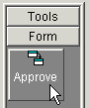

11 The PO has now been approved. An email will automatically be sent to the person who
raised the PO informing them of this.

Continue to Approve or Reject the selected PO’s as required.

When you have actioned the last PO selected you will be taken back to the “Work with
Orders Awaiting Approval” screen.

12 Click the 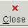 button at the top to return to your menu. Then Click on File and Exit.

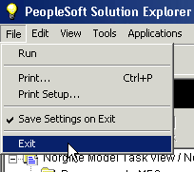

Reject Approval

13 Position your cursor over the first box of the PO line. The cursor will change to a small
black arrow Click once and the line will be highlighted

14 On the top left hand side of the screen click the “Reject” button (under the word “Row”)

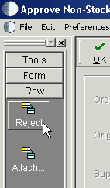

15. Click in the Remarks field and add some explanatory text (optional)

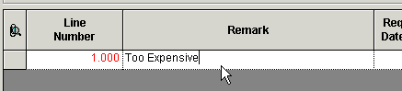

16. Then at the top of the screen click the “OK” button.

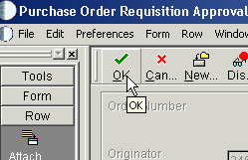

17. The selected PO line has now been rejected and an email will automatically be sent to the
person who raised the Purchase Order informing them of this.

If you selected more than one PO the details of the next PO will be shown as per step 7.

Continue to Approve or Reject the selected PO’s as required.

When you have actioned the last PO selected you will be taken back to the “Work with
Orders Awaiting Approval” screen.

18 Click the button at the top to return to your menu. Then Click on File and Exit.

